Lead Placement

Chest Leads
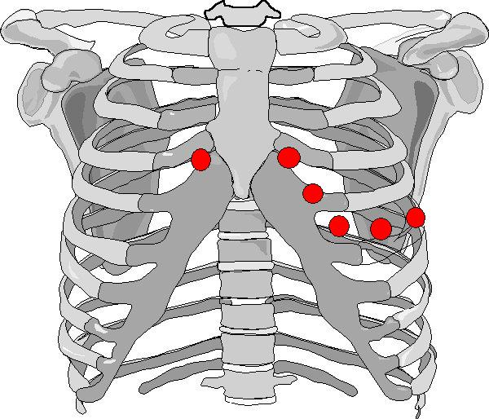

V1 – 4th intercostal space – Right sternal edge
V2 – 4th intercostal space – Left sternal edge
V3 – Midway between V2 & V4
V4 – 5th intercostal space – midclavicular line
V5 – Midway between V4 & V6
V6 – 5th intercostal space – mid axillar line

Limb Leads

Red – Right wrist
Yellow – Left arm
Green – Left ankle
Black – Right ankle

